Tornado Alley
Find and check the ending after each adventure. After you read all eight endings, rank them from (1) most favorite ending to (8) least favorite ending.

□ | I survive the tornado in the shelter. After the tornado, I interview the people in the shelter and write a news story. My story is a big hit! #_____
□ | Andy, Jo, and I survive the tornado in a closet under the stairs. When we come out of the closet, the rest of the house is gone! #_____
□ | The tornado picks up the car and throws it. We die and our story is on the news. #_____
□ | I survive the tornado in the bathroom with Dorothy’s family. Boomer the dog is safe, too!  #_____
□ | Andy tries to go faster than the tornado in the car, but he can’t. The tornado hits the car. #_____
□ | I am killed by a piece of debris. Boomer and Dorothy’s family are safe. #_____
□ | I record a video of the tornado with my phone. I can’t get in the shelter and am killed by the tornado. My video is on YouTube.  #_____
□ | 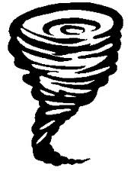  Andy, Jo, and I get stuck in a cornfield. I see the inside of a tornado!  #_____

